**NANDHA ENGINEERING COLLEGE**

**ERODE–638052 (Autonomous)**

**(Affiliated to Anna University, Chennai)**



**DEPARTMENT OF ARTIFICIAL INTELLIGENCE AND DATA SCIENCE**

**22AIC14 – INTERNET OF THINGS AND ITS APPLICATIONS**

**MINI PROJECT REPORT ON**

**TOPIC – DRIVER ANTI-SLEEP DEVICE USING ESP32-CAM**

**Submitted by**

|  |  |
| --- | --- |
| **REGISTER NUMBER** | **NAME** |
| **22AI002** | **ARAVINNDHAN A** |
| **22AI017** | **HARISH S.S** |
| **22AI056** | **VELUSAMY G** |

**NANDHA ENGINEERING COLLEGE**

**(An Autonomous Institution, Affiliated to Anna University, Chennai)**

**BONAFIDE CERTIFICATE**

**This is to certify that the project work entitled “DRIVER ANTI SLEEP DEVICE USING ESP32-CAM” is the Bonafide work of ARAVINDHAN A(22AI002), HARISH S.S(22AI017), VELUSAMY G(22AI056) who carried out the work under my supervision.**

**Signature of the Supervisor**

**Dr. K. Lalitha,**

**Assistant Professor,**

**Department of AI & DS,**

**Nandha Engineering College,**

**Erode – 638052.**

**Signature of the HOD**

**Dr. P. Karunakaran,**

**Head of the Department,**

**Department of AI & DS,**

**Nandha Engineering College,**

**Erode – 638052.**

**Submitted for End semester PBL review held on ______________**

**DRIVER ANTI-SLEEP DEVICE USING ESP32 CAM**

**AIM:**

To design and implement a real-time drowsiness detection system using the ESP32-CAM module. This system monitors the driver's eye movements and alerts them in case of prolonged eye closure, aiming to reduce the risk of accidents caused by driver fatigue.

**SCOPE:**

The **drowsiness detection system using ESP32-CAM** has a wide-ranging scope due to its potential applications in ensuring road safety, its affordability, and its ability to be integrated into various environments.

**BRIEF HISTORY:**

The development of **drowsiness detection systems using the ESP32-CAM** reflects evolution of driver safety technologies, embedded systems, and real-time monitoring solutions.

**PROPOSED METHODOLOGY:**

The drowsiness detection system is designed by integrating multiple hardware components, including the ESP32-CAM for capturing real-time video, an MQ3 alcohol sensor for detecting alcohol levels, a 16x4 LCD display for status updates, a SIM800C GSM module for sending SMS alerts, a 5V DC buzzer for audio warnings, a 12V DC relay for controlling vehicle ignition, and a 12V 1-amp DC adaptor for power. The ESP32-CAM captures live frames and preprocesses them using OpenCV to detect the driver’s face and eye status.

A machine learning algorithm analyzes the eyes’ state over consecutive frames, determining if they are closed for an extended period, which indicates drowsiness. Simultaneously, the MQ3 sensor measures alcohol levels in the driver’s breath, triggering alerts if thresholds are exceeded.

When drowsiness or alcohol presence is detected, the system activates a buzzer, displays warnings on the LCD, disables vehicle ignition via the relay, and sends SMS alerts through the GSM module to emergency contacts. Using the ESP32’s Wi-Fi capabilities, the system logs data to an IoT platform, enabling real-time monitoring and analysis. The solution undergoes extensive testing under varied conditions to optimize thresholds and ensure accuracy. Additional features, such as head posture analysis and yawning detection, can be integrated in the future to enhance functionality. This cost-effective, reliable system is aimed at preventing accidents and improving road safety.

**COMPONENTS REQUIRED:**

|  |  |  |
| --- | --- | --- |
| **S.NO** | **COMPONENTS** | **NO’S** |
| 1 | ESP32 microcontroller | 1 |
| 2 | ESP32 cam | 1 |
| 3 | MQ Sensor | 1 |
| 4 | 12V Relay | 1 |
| 5 | 16*4 LCD display | 1 |
| 6 | GSM module | 1 |
| 7 | 5V buzzer | 1 |
| 8 | DC motor | 1 |

**DESCRIPTION:**

The Drowsiness Detection System using ESP32-CAM is an innovative and cost-effective solution designed to enhance road safety by preventing accidents caused by driver fatigue or alcohol impairment. This system employs the ESP32-CAM module for real-time video capture, enabling continuous monitoring of the driver’s facial features, particularly the eyes, to detect signs of drowsiness. By utilizing computer vision techniques and machine learning algorithms, the system analyzes the driver’s eye status (open or closed) over successive frames to identify prolonged closure, a key indicator of drowsiness.

Additionally, the system integrates an MQ3 alcohol sensor to measure the alcohol concentration in the driver’s breath, ensuring the vehicle is operated safely. Alerts are triggered in case of drowsiness or alcohol detection, with multiple mechanisms in place: a buzzer sounds an alarm, a 16x4 LCD display shows warning messages, and a SIM800C GSM module sends SMS notifications to emergency contacts. For added safety, the system uses a 12V DC relay to control the vehicle’s ignition, effectively stopping the vehicle if unsafe conditions are detected.

The system also leverages IoT technology via the ESP32’s Wi-Fi module to log and transmit real-time data to an online platform, enabling continuous monitoring and analysis. Compact, efficient, and easy to install, the Drowsiness Detection System provides a robust safeguard for drivers and passengers, combining advanced technology with practical application to reduce road accidents.

**CODING:**

#include <WiFi.h>

#include <WebServer.h>

#include <Wire.h>

#include <LiquidCrystal_I2C.h>

#define ssid "Driver" // WiFi SSID

#define password "project123" // WiFi password

#include "MAX30100_PulseOximeter.h"

long GPS;

long GPS1;

int AcX, AcY, AcZ, fl, y, x, f2, ge, te, hb, hb1, sdnn, rmssd, sp, al;

//SoftwareSerial mySerial(15, 13);

LiquidCrystal_I2C lcd(0x27, 16, 2);

String t = "NULL";

String t1 = "NULL";

String t2 = "NULL";

String t3 = "NULL";

char p ;

String etatLed = "";

#define button1 16

WebServer server ( 80 );

String getPage() {

String page = "<html lang=fr-FR><head><meta http-equiv='refresh' content='2'/>";

page += "<title>DRIVER SLEEP MONITORING SYSTEM</title>";

page += "<style> body { background-color: #9AFEFF; font-family: Arial, Helvetica, Sans-Serif; Color: #000088; }</style>";

page += "</head><body><h1>DRIVER SLEEP MONITORING SYSTEM</h1>";

page += "<ul><li>DRIVER STATUS: ";

page += t1;

page += "</li></ul>";

page += "<ul><li>ALCOHOL STATUS: ";

page += t2;

page += "</li></ul>";

return page;

}

void handleRoot() {

if ( server.hasArg("LED") || server.hasArg("LED1")) {

handleSubmit();

} else {

server.send ( 200, "text/html", getPage() );

}

}

void handleSubmit() {

// Actualise le GPIO / Update GPIO

String LEDValue, LEDValue1;

LEDValue = server.arg("LED");

LEDValue1 = server.arg("LED1");

//Serial.println("Set GPIO "); Serial.print(LEDValue);

if ( LEDValue == "0" ) {

// Serial.println ("B");

digitalWrite(14, LOW);

t = "MOTOR OFF";

server.handleClient();

delay(2000);

etatLed = "OFF";

server.send ( 200, "text/html", getPage() );

} else if ( LEDValue == "1" ) {

// Serial.println ("A");

digitalWrite(14, HIGH);

etatLed = "ON";

t = "MOTOR ON";

// hb = random(3,5);

//lcd.setCursor(0,10);

// lcd.print("I:");

// lcd.print(hb);

server.handleClient();

delay(2000);

server.send ( 200, "text/html", getPage() );

} else {

// Serial.println("Err Led Value");

}

}

void setup() {

Serial.begin(9600);

server.handleClient();

WiFi.softAP(ssid, password);

IPAddress myIP = WiFi.softAPIP();

// On branche la fonction qui gère la premiere page / link to the function that manage launch page

server.on ( "/", handleRoot );

server.begin();

serialEvent();

lcd.init();

// turn on LCD backlight

lcd.backlight();

lcd.setCursor(0, 0);

lcd.print("DRIVER");

lcd.setCursor(0, 1);

lcd.print("DROWSINESS SYSTM");

delay(200); // Pause for 2 seconds

init_modem();

// mySerial.begin(9600);

// pinMode(2, OUTPUT);

pinMode(12, INPUT_PULLUP);

pinMode(23, OUTPUT);

pinMode(14, OUTPUT);

digitalWrite(23, LOW);

digitalWrite(14, LOW);

randomSeed(analogRead(0));

//digitalWrite(2, LOW);

delay(1000);

//digitalWrite(12, LOW);

lcd.clear();

}

void init_modem()

{

Serial.print("AT\n\r");

delay(300);

Serial.print("ATE0\n\r");

delay(300);

Serial.print("AT+CREG=1\n\r");

delay(300);

Serial.print("AT+CSMS=1\n\r");

delay(300);

Serial.print("AT+CSCS=\"GSM\"\n\r");

delay(300);

Serial.print("AT+CMGF=1\n\r");

delay(300);

Serial.print("AT+CNMI=2,2,0,0,0\n\r");

delay(300);

Serial.print("AT+CNMI=1,2,0,0,0");

delay(300);

}

void send_sms1()

{

init_modem();

Serial.println("AT");

delay(300);

Serial.println("ATE0");

delay(300);

Serial.println("AT+CMGF=1");

delay(300);

Serial.println("AT+CMGS=\"9025752023\"\r"); // Replace x with mobile number

delay(300);

Serial.print("DRIVER SLEPT ALERT");

// Serial.print("11.");

// Serial.println(GPS);

// Serial.print("N");

// Serial.print("78.");

// Serial.println(GPS1);

// Serial.print("E");

// Serial.print("Temp.");

// Serial.println(c1);

// Serial.print("HB.");

// Serial.println(c2);

delay(500);

Serial.write((byte)0x1A);

delay(3000);

lcd.clear();

lcd.print("sms sent1");

delay(2000);

}

void send_sms2()

{

init_modem();

Serial.println("AT");

delay(300);

Serial.println("ATE0");

delay(300);

Serial.println("AT+CMGF=1");

delay(300);

Serial.println("AT+CMGS=\"9025752023\"\r"); // Replace x with mobile number

delay(300);

Serial.print("ALCOHOL DRUKEN ALERT");

// Serial.print("11.");

// Serial.println(GPS);

// Serial.print("N");

// Serial.print("78.");

// Serial.println(GPS1);

// Serial.print("E");

// Serial.print("Temp.");

// Serial.println(c1);

// Serial.print("HB.");

// Serial.println(c2);

delay(500);

Serial.write((byte)0x1A);

delay(3000);

lcd.clear();

lcd.print("sms sent2");

delay(2000);

}

void serialEvent()

{

while (Serial.available())

{

char inChar = (char)Serial.read();

//Serial.print(inChar);

if (inChar == 'A')

{

t1 = "SLEPT-->> EMERGENCY ALERT";

t2 = "NORMAL";

digitalWrite(23, HIGH);

lcd.setCursor(0, 0);

lcd.print("DRIVER ");

lcd.setCursor(0, 1);

lcd.print("SLEPT.");

//server.handleClient();

delay(10000);

send_sms1();

delay(10000);

delay(10000);

lcd.clear();

}

else

{

t1 = "SLEPT-->> EMERGENCY ALERT";

t2 = "NORMAL";

digitalWrite(23, HIGH);

lcd.setCursor(0, 0);

lcd.print("DRIVER ");

lcd.setCursor(0, 1);

lcd.print("SLEPT");

//server.handleClient();

delay(10000);

send_sms1();

delay(10000);

delay(10000);

lcd.clear();

}

}

}

void loop()

{

al = analogRead(34);

serialEvent();

if (al<200)

{

serialEvent();

t2 = "ALCOHOL DRUNKEN-->> EMERGENCY ALERT";

t1 = "NORMAL";

lcd.clear();

lcd.setCursor(0, 0);

lcd.print("ALCOHOL");

lcd.setCursor(0, 1);

lcd.print("DRIVING");

server.handleClient();

delay(500);

digitalWrite(23, HIGH);

send_sms2();

delay(10000);

delay(10000);

}

Else

{serialEvent();

t2 = "NORMAL";

t1 = "NORMAL";

lcd.clear();

lcd.setCursor(0, 0);

lcd.print("NORMAL");

server.handleClient();

digitalWrite(23, LOW);

delay(500);

   }

  }

**SCREENSHOTS:**

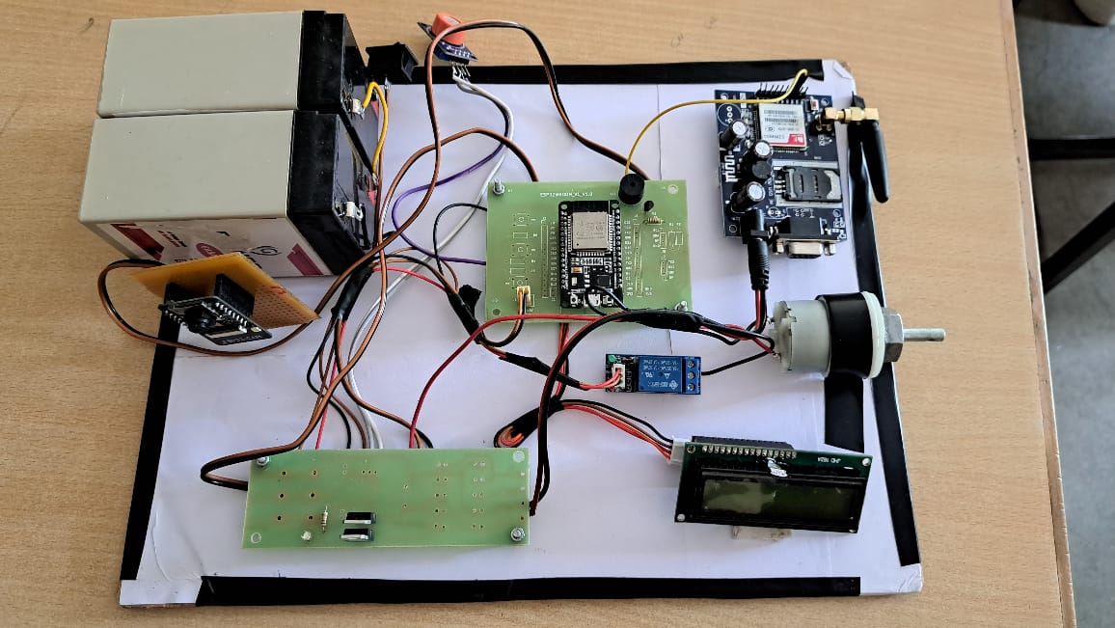

**OUTPUTS:**

**Alcohol Detection**

* **Detects alcohol levels using the MQ3 sensor and triggers alerts if levels exceed the threshold.**

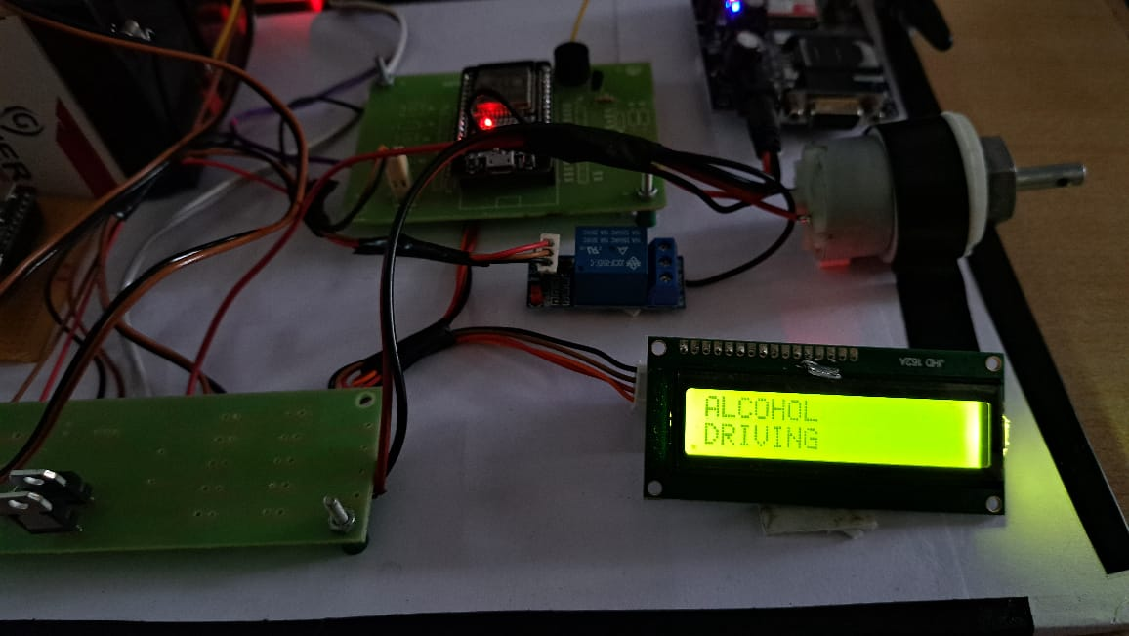

**Drowsiness Detection**

* **Real-time detection of closed eyes or signs of drowsiness.**
* **Alerts the driver when drowsiness is detected.**

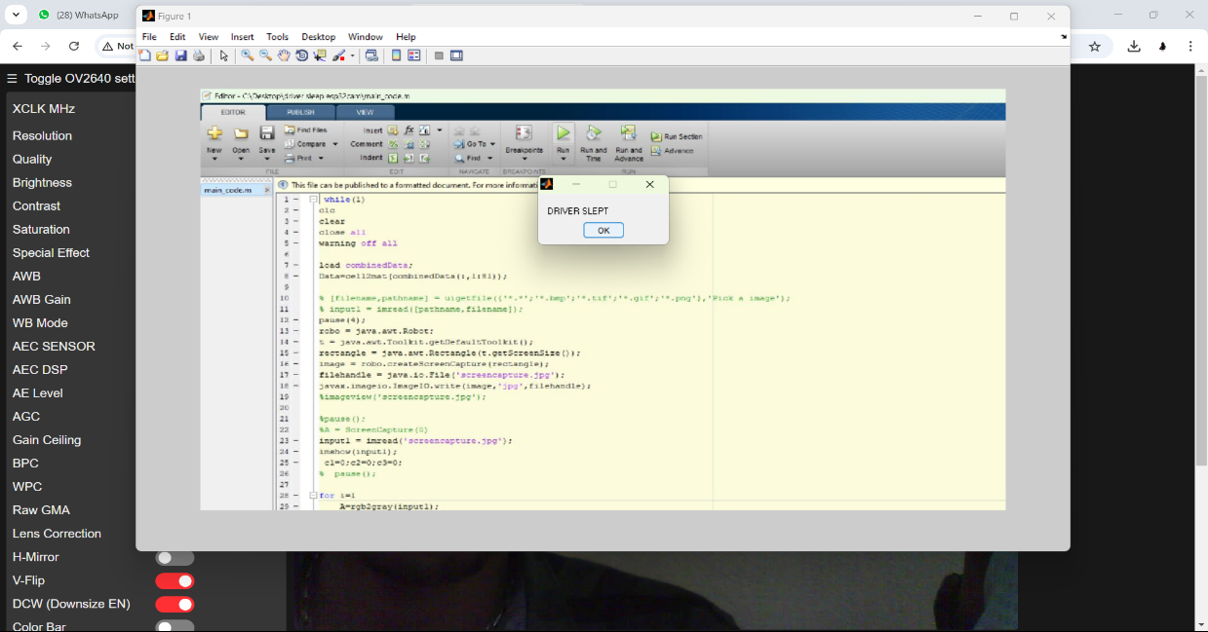

**Alerts and Notifications**

* **Audible alerts (buzzer) to wake up the driver.**
* **SMS notifications sent to emergency contacts using the GSM module.**

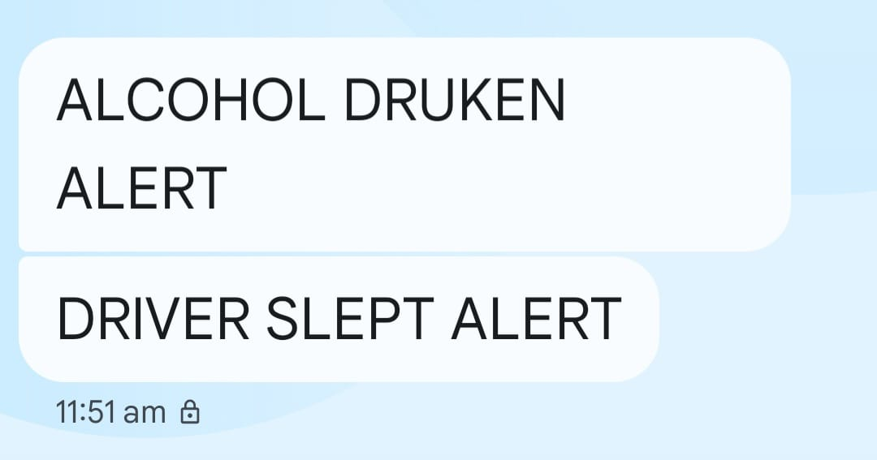

**LIMITATIONS:**

1. **Limited Processing Power**: Restricted computational capacity limits the use of advanced AI models.
2. **Lighting Dependency**: Struggles in low-light conditions without additional IR components.
3. **Network Dependence**: IoT features require consistent internet, which may not always be available.
4. **False Positives/Negatives**: Potential for misclassification, leading to incorrect alerts.
5. **Single Sensor Reliance**: Limited to visual data, missing other fatigue indicators like posture or vitals.
6. **Limited Range**: Only monitors the driver directly in front of the camera.
7. **Power Consumption**: High energy usage from camera and Wi-Fi can drain batteries quickly.
8. **Privacy Concerns**: Capturing and processing video data may raise privacy and security issues.
9. **Hardware Sensitivity**: Performance can be affected by vehicle vibrations or extreme conditions.
10. **Cost of Additional Features**: Adding GPS, IR cameras, or advanced sensors increases system cost.
11. **Driver Compliance**: Drivers may ignore or disable alerts, reducing effectiveness.
12. **Environmental Limitations**: Poor performance in extreme weather like fog, rain, or bright sunlight.
13. **Scalability Issues**: System may require significant upgrades for fleet-level deployment.
14. **Frequent Calibration**: Requires recalibration for different drivers or environments to remain accurate.
15. **Limited Health Monitoring**: Does not track critical health indicators like heart rate or stress.

**FUTURE ENHANCEMENTS:**

1. **AI-Based Analytics**: Use advanced machine learning models like TensorFlow Lite for improved accuracy.
2. **Yawning Detection**: Add facial landmark tracking to detect yawning and other fatigue signs.
3. **Night Vision**: Integrate IR cameras for effective detection in low-light conditions.
4. **Driver Identity Recognition**: Implement facial recognition for driver verification and personalized settings.
5. **Emergency Location Tracking**: Add a GPS module to send the vehicle’s location during emergencies.
6. **Automatic Vehicle Control**: Enable slowing or stopping the vehicle if the driver remains unresponsive.
7. **IoT Connectivity**: Use cloud platforms like Firebase for real-time data storage and monitoring.
8. **Enhanced Alerts**: Include vibrating seats, steering wheels, or Heads-Up Displays (HUD) for better warnings.
9. **Health Monitoring**: Add sensors to measure heart rate or temperature for health tracking.
10. **Multi-Driver Profiles**: Support personalized settings for different drivers.
11. **Mobile App Integration**: Develop an Android/iOS app for alerts, video feeds, and system controls.
12. **Energy Optimization**: Enhance power efficiency for longer system uptime.
13. **Alcohol Detection Upgrade**: Use advanced gas sensors for accurate alcohol detection.
14. **Affordable Design**: Reduce costs to make the system more accessible for wider use.
15. **Data Security**: Strengthen encryption and secure communication for privacy protection.

**CONCLUSION:**

The Drowsiness Detection System using ESP32-CAM is an effective and affordable solution for improving road safety. By monitoring the driver’s eyes and alcohol levels, it can quickly detect drowsiness or intoxication and take action to prevent accidents. The system provides alerts through a buzzer, LCD display, SMS notifications, and can even stop the vehicle if needed.

With its simple design, real-time monitoring, and potential for future upgrades like yawning or head posture detection, this system is a reliable and practical tool for reducing road accidents and keeping drivers and passengers safe.